ADANA TRAINING MUN PROGRAMME 2019

UNITEDiNATIONSiHUMANi

RIGHTSiCOUNCIL

___________________________________________________________________________________________

PreservationiofiHumaniRightsiiniPrisons

Emergence of the situation in Palestine

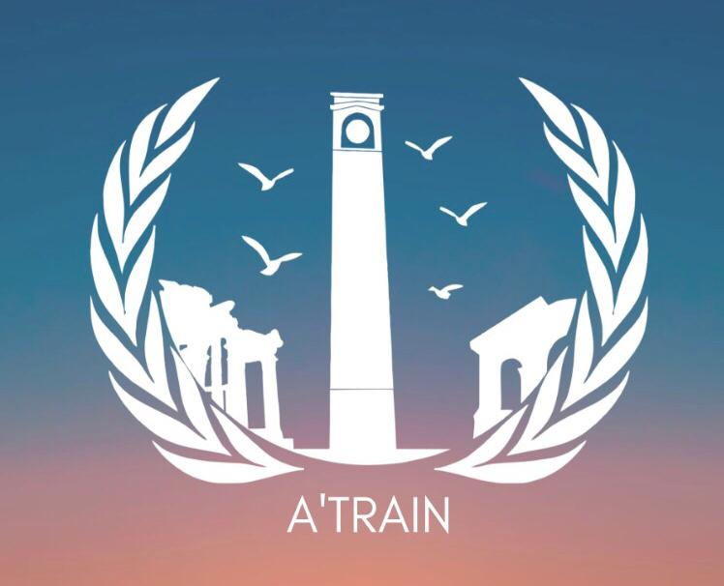

iCommittee Director:i

Mehmet BÜYÜK

Committee Director:i

Arda Noyan KARAŞOĞLUi

Rapporteur: Yağmur AKSOY
ADANA TRAINING MUN PROGRAMME 2019 - Mehmet BÜYÜK

TABLEIOFICONTENTS

I.iLetterifromitheiSecretary-Generali 3

II.iLetterifromiCommittee Directorsi 3

IV.iIntroductionitoiCommitteei …4

V.iIntroductionitoiAgendaiItemiA……………………………………………………………………..5

A.i Current Outlook …5

B.i Universal Declaration of Human Rights……………………………………………………..….6

C.i Standard Minimum Rules for the Treatment of Prisoners ….…6

D.i Basic Principles for Treatment of Prisoners ..7

E.i Block Positions……………………………………………………………………………………7-9

H.iQuestionsitoiBeiAddressed ..9

J.iFurtheriReading .10

VI.iIntroductionitoiAgendaiItemiB 17-26

A.iHistorical Background……………………………………………………………………….10-11

B. Arab-Israeli War (1948-1949) 11

C. Six Days War (1967) 12

D.i Camp David Accords (1978)…………………………………………………………………. 12

E.i The Palestinian Liberation Organization…………………………………………....... 13

F.i Intifadas……………….………………………………………………………………….........14-15

G.i Overview at the humanitarian crisis………………………………………………………… 15-16

H.i Humanitarian Dimension…………………………………………………………….………. 16-21
.
J.i Questions to be adressed…………………………………………………………………… 21

ADANA TRAINING MUN PROGRAMME 2019

I.iLetterifromiSecretary-General

Highly Esteemed Participants of Human Rights Council,

While being fraught with utter elation and contentment to be serving you as the Secretary-General of the Conference, I am thrilled to approve the academic document written by the mastermind Associate Committee Director, Mehmet BÜYÜK whom never ever had disappointed me on any matter regarding the preparation process of study guides. I also would like to utter my appreciation for the designated sir/madam Committee Director, Arda Noyan KARAŞOĞLU, and Yağmur AKSOY, for working with us.
The Human Rights Council is an inter-governmental body within the United Nations system responsible for strengthening the promotion and protection of human rights around the globe and for addressing situations of human rights violations and make recommendations on them.
To conclude, on behalf of the Academic and Organization teams, I would like to stress my gratitude and thrill to be welcoming you to ADANA TRAINING MUN PROGRAMME 2019 which will be opening a new era in the MUN community of Adana.
Faithfully,
Metehan KANLI, Secretary-General of ADANA TRAINING MUN PROGRAMME 2019

II.iLetterifromiCommittee Directors

Esteemed Participants of Human Rights Council,

My name is Mehmet BÜYÜK and it is my utmost pleasure and honor to be assigned as the Associate Committee Director of the Human Rights Council.
I am thrilled to shape an enviroment for humanitarian struggles for so many eager delegates. This symposium will provide you with a unique opportuinty to experience firsthand how to UNHRC operates, to learn more about national perspectives on prisoner rights and the emergence of the situation in Palestine. You will experience the negotiations of international and national law as well as redefining the scope of human rights.
Note that Human Rights Council is apt for both experienced, and inexperienced MUNers. All inquiries concerning the committee can be submitted to the responsible Secretariat representatives.

Accept my best wishes for and enjoyable and productive series of deliberations.
I strongly encourage you to read and comprehend this study guide in full for understanding the topics that are to be discussed in the committee. If you have any questions, I am more than happy to help you with them. Please do not hesitate to contact me via

esfenvalde@gmail.com - +90 5071302685
Kindest regards,
Mehmet BÜYÜK , Associate Committee Director responsible for HRC

ADANA TRAINING MUN PROGRAMME 2019

III. Introduction to the Committee

TheiHumaniRightsiCounciliisiaisubsidiaryiorganiofitheiGeneraliAssemblyiwithitheitaskitoii strengtheniandipromoteihumanirightsialliarounditheiglobeiandiforiaddressingisituatiosofiihu-manirightsiviolationsiandimakeirecommendationsionithem.iItitakesiintoiaccountiaiwideibody iofitopicsiincludingihumanirightsiissuesiandisituationsithatirequireiitsiattentioniandiiimmedia teisolutions.iItsiofficeiisisituatediiniGeneva.
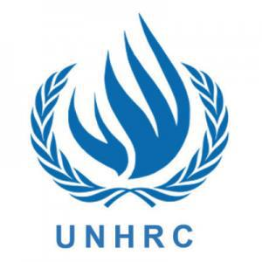

TheiHumaniRightsiCounciliconsistsiofi47iUNiMemberinationsithatiareielectedibyitheiUNiG eneraliAssembly.iTheiHumaniRightsiCouncili(HRC)ireplaceditheiformeriUnitediNationsii CommissionioniHumaniRightsi(UNCHR),iwhichiwasiestablishediini1946.iTheiHumanii Rightsicounciliexitsitoimakeisureithatiindividualsiandicommunitiesiarounditheiworldiareinoti beingideprivediofibasicihumanirights.iTheyistriveitoiprovideiuniversality,iinterdependenceii andiindivisibilityiofiHumaniRights,iinherenticooperation.iTheiriscopeiisinotionlyilimiteditoi MemberiStatesibutialsoitoiNoniGovernmentaliOrganizationsi(NGOs)iandinationaliHumanii Rights institutions
IV.IntroductionitoiAgendaiItemiA
(PreservationiofiHumaniiRightsiiniPrisons)

A. CurrentiOutlook

Despiteiwidespreadiandiferventieffortsitoipromoteihumanirights,itheibasicirightsiofifelonsii areiseldomiconsidered.iAreihumanirightsitrulyi“inalienable,”ieveniwhenithoseiclaimingithem haveiinfringedionitheirightsiofiothersiasiwithicriminals?iThisiideologicaliquestioniliesiatithei heartiofitheiUnitediNationiHumaniRightsiCouncil’sidiscussion.¹
iAsistatedibyitheiUnitediNationsiOfficeioniDrugsiandiCrimei(UNODC),iaiprisonisentenceii shouldionlyibeiai“deprivationiofitheibasicirightitoiliberty.”iUnfortunately,ithereihaveibeeni inumerousiincidentsiiniprisonsiallioveritheiworldithaticontraveneiotherihumanirights.ii Whetheritheseiinfringementsiareidueitoiprisoniconditionsioriabusiveiactions,itheiUNHRCiisi taskediwithisuggestingipossibleisolutions.
İ
Venezuela,iaiSouthiAmericanicountryiwithiaitaintedihumanirightsirecord,iisioneiofitheii worstioffendersiwheniiticomesitoiinhumaneiprisoniconditionsiandicorruptijusticeisystems.ii Notionlyiareithereireportsiofiextrajudicialikillings,ibutiprisoniovercrowdingialsoioftenileadsii
toiunsanitaryiconditions,imalnutrition,idisease,iriots,ianditheiuseiofiexcessiveiforceiagainsti inmates.²
iOvercrowdingiofiprisonsiisinotiaihumanirightsiviolationiiniitself,ibutiitioftenileadsitoihealth problemsiandiviolence.iAdditionally,itortureiandisolitaryiconfinementiiniprisonsiareiviewedi byimanyiasiunnecessarilyicrueliandiunusualipunishments,iplacingithemiwithinitheipurviewii ofitheiUNHRC’siexamination.
___________________________________
1 "The Universal Declaration of Human Rights," UN News Centre, http://www.un.org/en/documents/udhr/
- "World Report 2012: Venezuela," Human Rights Watch, http://www.hrw.org/world-report- 2012/world-report-2012-venezuela

Note: You can check the history of prison with; https://www.oxfordbibliographies.com/view/document/obo-9780195396607/obo-9780195396607-0189.xml

B. UniversaliDeclarationiofiHumaniRights

iOneiofitheimostimonumentalihumanirightsidocumentsiofitheilasticentury,itheiUniversali DeclarationiofiHumaniRightsiwasiadoptedibyitheiUnitediNationsiini1948.⁶iArticlesi5,i9,i10,i andi11iareialliofiparticulariimportanceitoitheitopiciatihandiasitheyidealidirectlyiwithilegali systemsiandiarrests,ihoweveritheigeneralispiritiofitheiDeclarationiasiaiwholeiappliesiiniterms iofithei“equalityiinidignityiandirights”iofiprisonersiuniversally.
C. StandardiMinimumiRulesiforitheiTreatmentiofiPrisoners

TheiStandardiMinimumiRulesiforitheiTreatmentiofiPrisonersiareiaisetiofinon-bindingipoliciesiadoptedibyitheiUNiini1955itoiestablishiaigeneraliconsensusionihowi prisonersioughtitoibeiregardedianditreated,iratherithanitoidictateipreciselyihowiprisoni systemsishouldibeirun.iTheifirstisectioniofitheidocumentiincludesiprovisionsiforihousing,I clothing,iseparation,ihygiene,ileisure,imedicaliservices,ieducation,iandieveniwork.

Theiguidelinesistressitheiimportanceiofirespectingireligiousibeliefsiandipracticesiwheni possible,iasiwelliasitheipresenceiofireligiousiliterature.iTheigoodiconductiofiprisonistaffiisi alsoiemphasized,iasi“itiisionitheiriintegrity,ihumanity,iprofessionalicapacityiandipersonali suitabilityiforitheiworkithatitheiproperiadministrationiofitheiinstitutionsidepends.”⁷Notably,I theirulesialsoipromoteiworkiiniprisonsiasilongiasitheiworkiisi“meaningful,iproductive,iandi usefulitoitheiprisoners.”
iTheisecondipartiaddressesispecificineedsiofidisadvantagedigroups,isuchiasithoseiwithi mentaliailments,iandinotesitheirispecificineediforiindividualizedicare althoughithisiisiofteninotiprovidediiniprisonisystems.
___________________________________
- "The Universal Declaration of Human Rights," UN News Centre, http://www.un.org/en/documents/udhr/.
D. BasiciPrinciplesiforitheiTreatmentiofiPrisonersi

TheiUNiGeneraliAssemblyipassedithisisetiofiprinciples,iproposedibyitheiOfficeiofitheiHighi CommissioneriforiHumaniRights,iini1990.⁸iSimilaritoitheiRules,itheiPrinciplesiareilargelyi basedioniideologies,iandiareinotilegallyienforced.iTheyifocusiratherioniaiseriesiofistepsithati
williculminateiinitheisuccessfulireintegrationiofiinmatesibackiintoisociety.iFirstly,iratheri

thanidepriveiinmatesiofimostiofitheirirights,itheseiPrinciplesipromoteithati“exceptiforithosei

limitationsithatiareidemonstrablyinecessitatedibyitheifactiofiincarceration,ialliprisonersishalli

retainitheihumanirightsiandifundamentalifreedomsisetioutiinitheiUniversaliDeclarationiofi

HumaniRights.”iAdditionally,itheidocumentistressesithei“fullidevelopmentiofitheihumani

personality”ianditheilimitation,iorieveniabolition,iofisolitaryiconfinement.

E. BlociPositions

iTheiprisonisystemsiinimosticountriesiareideeplyiflawed,iholdingianiexcessiofiinmatesiwithi tooifewiresources.iThoughithereiwillibeidisagreementsibetweenicountriesiwithidifferingi financialiandisocialicircumstancesiasitoihowitoiresolveitheseiissues,itheyiareiindubitablyi omnipresentiandidemandimeaningfuliaction.iTheiblocsibelowiserveitoioutlineiailimitedi numberiofikeyiperspectivesiandiconsiderationsiforiMemberiStates.

___________________________________
- "Basic Principles for the Treatment of Prisoners," United Nations Office of The High Commissioner for Human Rights, http://www.ohchr.org/EN/ProfessionalInterest/Pages/BasicPrinciplesTreatmentOfPrisoners.aspx.

1. LatiniAmerica

iLatiniAmericaniprisonsiareiwidelyireputediasibeingitheiworstiinitheiworld,inotionlyiini termsiofiovercrowdingibutialsoiinitermsiofiviolence.⁹iThereiisilittleiemphasisionitheihumani rightsiofiprisonersiorirehabilitation,ileadingitoihighirecidivismiratesiandinumerousiriots.i However,iaifewicountries,isuchiasitheiDominicaniRepublic,iareimoreiprogressiveiinitheiri prisonisystems,iincorporatingieducationiandireformingitheisystemiasiaiwhole.iReducingiover crowdingiwillibeioneiofitheimostidifficultistepsiforiSouthiandiCentraliAmericanicountries,I asievenioffendersiofipettyicrimesiareiincarceratedidueitoi“ironifist”iandi“toughionicrime” ipolicies. ¹⁰

2. Asia

iConditionsiiniAsianiprisonsiareinotiparticularlyipromising,iwithicountlessiaccountsiofi overcrowding,imaltreatment,iandiviolence.iCertainiAsianicountries,isuchiasiJapan,idoinoti haveiproblemsiwithiovercrowdingibutiinsteadifaceicriticismiforiharshidisciplinaryimeasures. ¹¹iNevertheless,iJapanidoesinotihaveihighirecidivismiratesiandiemploysiaifewirehabilitationi programsiiniitsiprisons.iAsiaiwhole,iprisonisystemsiinitheseicountriesineedimuchi improvementiandiwillirequireimonumentalishiftsiinigovernmentipolicyiasiwelliasiresourcei allocationitoiachieveiaimoreihumaneiandieffectiveisystem.
3. Africa

iThoughiconditionsiinimostiAfricaniprisonsiareidire,ipublicityisurroundingitheiabhorrenti circumstancesihasileditoisomeireforms.iAlternativeisentencingiandirehabilitationiisi becomingimoreiprevalentiiniSouthiAfrica,iUganda,iandiBotswana,idespiteitheistrainioni resources.iUnderfundediandiovercrowdediAfricaniprisonsifaceisewage,iventilation,iandi generalihygieneiproblems,ianditheseichallenges,icouplediwithiineffectiveiwiderijusticei systems,imakeitheisituationiextremelyidifficult.iHowever,iasinotedibyitheiSuriInternational iJournalioniHumaniRights,itheseiconditionsioughtitoibeitakeniintoicontextialongsideithei “overallideprivationiofitheicontinent”ianditheilackiofiavailableiresources.iOfiparticulari importanceiinidecrepitiprisonsiisitheiprevalenceiofidiseasesiandiprisonerirape,iwhichi servesiespeciallyitoispreadiHIV/AIDS.¹²
4. Europe

iThoughiEuropeiundoubtedlyileadsitheiworldiwheniiticomesitoihumanirightsiiniprisons,iits iprisonisystemsiareinotiwithoutifault.iWhileilessiprevalentithaniiniotheriregions,iguardi brutalityiandiinadequateimentalihealthcareiremainisignificantiissuesitoibeiconfronted.iIniless iwealthyiEuropeanistates,iincludingimanyipostSovietinations,iprisoniconditionsimoreiclosely iresembleithoseiiniAsiaiandiAfrica.iSolitary Confinementiandiprisoneridisenfranchisementi
continueitoibeicontroversialiissuesiinitheseistates.iHistoricalitrackirecords,ihowever,ihavei showniEuropeanicountriesitoibeiveryivocaliinitheidefenseiofihumanirights,ileadingithemitoi supportitheiethicaliandihumaneitreatmentiofi citizensiiniprisoniasiwell.¹³
F.iQuestionsitoiBeiAddressed

1.iHowicaniUNHRCiencourageirespectiforihumanidignityiwithiniprisons?iHowicanithisibei

applieditoiwardensiandiprisonistaff?i

2.iShouldieducationiandicultureibeiintegratediintoiprisons?iIfiso,ihow?

i3.iWhatistepsishoulditheiinternationalicommunityitakeitoiholdicountriesiaccountableifori

theiriprisoniconditions?i¹⁴

4.iHowidoieconomicifactorsiaffectitheiupholdingiofibasicihumanirightsiiniprisons?iHowi

shouldiresourcesibeiallocateditoibestiprotectiprisoners’irights?

I5.iWhatishouldiUNHRC’silong-termiroleibeiiniaddressingihumanirightsiiniprisons?

- "Prisons in Latin America: A Journey into Hell," The Economist, September 22, 2012, http://www.economist.com/node/21563288.

- Marguerite Cawley, "Overcrowded CentAm Prisons Reflect Failed 'Iron Fist' Policies," InSight Crime, July 25, 2013, http://www.insightcrime.org/news- briefs/overcrowded-centam-prisons-reflects-failed-iron-fist-policies.

- Sheryl Wudunn, "Prisons in Japan Are Safe but Harsh," The New York Times, July 8, 1996, http://www.nytimes.com/1996/07/08/world/prisons-in-japan-are-safe-but-harsh.html.

- Jeremy Sarkin, "Prisons in Africa: An evaluation from a human rights perspective," SUR, http://www.surjournal.org/eng/conteudos/getArtigo9.php?artigo=9,artigo_sarkin.htm.

- American Friends Service Committee, "What is solitary confinement?" https://afsc.org/resource/solitary-confinement-facts.

G.iFurtheriReading

AiWiniforiDignity:ihttp://www.economist.com/node/18744637

iRetributionioriRehabilitation:ihttp://www.lawlibrary.ie/viewdoc.asp?Docid=144

HumaniRightsiandiPrisons:iAiManualioniHumaniRightsiTrainingiforiPrisoniOfficials:

https://afsc.org/resource/solitary-confinement-facts.

IV.IntroductionitoiAgendaiItemiA
(Emergence of the situation in Palestine)

Palestinians and Israelis have been fighting over control of the holy land for decades. This area is called the holy land because many religions believe that this land has holy buildings and monuments such as Dome of the Rock, Al-Aqsa Mosque and so on. Israeli zionists believe that they should live in the holy land because it is their home. Same goes for Palestinians as they define themselves a different ethnicity from Arabs and they think that they themselves deserve their own country to live in. When both nations claimed the same land as their own this disagreement led to catastrophic wars and misery

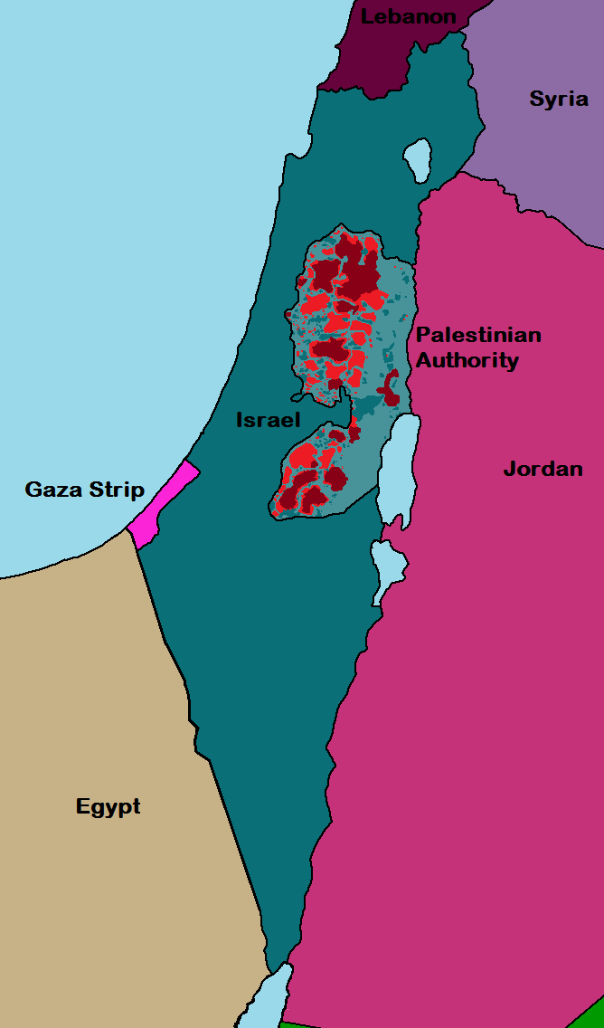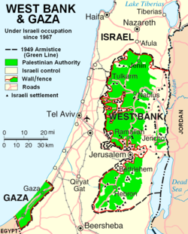
Map of British Mandate for Palestine

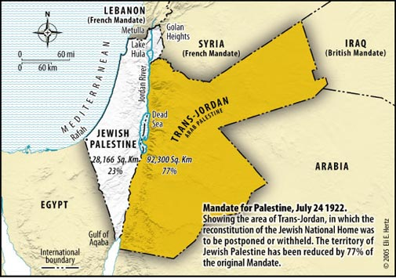
Map of Israel and Palestine according to UN Plan

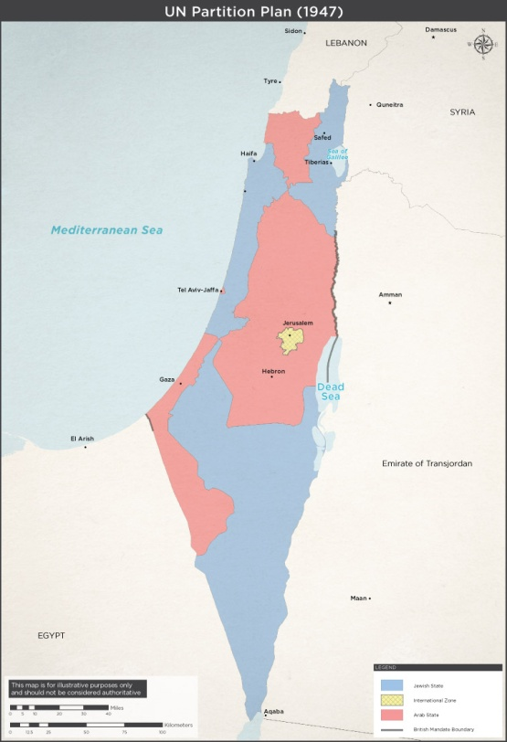
Arab-Israeli War (1948-1949)

Although Israel was quite comfortable with the new UN plan, Arabs thought of this plan as European colonialism trying to take their land away from them. Many of the Arab countries declared war on Israel to eradicate all Jews and install a unified Arabic Palestine. Israel won this war but in the process of doing so pushed well past their UN plan borders. As a result of this act, many Palestinians were forced out of their homeland creating an immense refugee wave. Many Jews fled from Arab-majority countries to arrive at Israel. This was the beginning of Arab-Israeli conflict which would affect people horribly decades and generations to come.

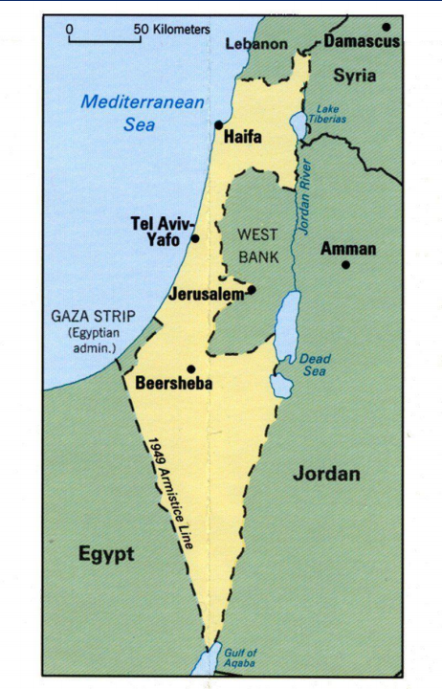
Six Days War (1967)

The Six-Days War was similar to Arab-Israel war and as the name suggests, it only lasted six days. When the war came to an end Israled had gained control over the West Bank from Jordan Golan Heights from Syria and both Gaza and the Sinai Peninsula from Egypt. This meant that Israel was now left responsible for governing the Palestinians, the people they fought for decades.

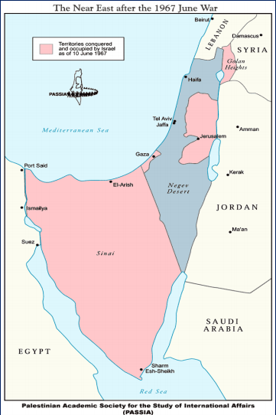

Camp David Accords (1978)

In 1978 Israel and Egypt signed the US-brokered Camp David Accords. Israel gave the Sanai back to Egypt in result of the peace treaty. This meant a great deal as it was deeply controversial to the Arab world. Egyptian president Anwar Sadat was assassinated because of the outrage against it. Over the next few decades, other Arab nations made peace with Israel even though there were no peace treaties signed by the nations. However, this didn’t change the fact that Israeli forces were still occupying Palestinian territories of the West Bank and Gaza. this is when the conflict became an IsraeliPalestinian problem.
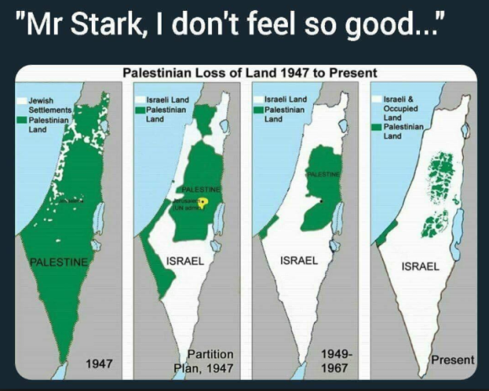
The Palestinian Liberation Organization

The Palestinian Liberation Organization was formed in 28th of May, 1964. Their main objective was to establish a Palestinian state and they didn’t hesitate to resort to violence and terrorism. PLO wanted to end Israel entirely and claim the land for Palestinians. Combat between PLO and Israel went on for years including an Israeli offensive against Lebanon to wipe out the group from Beirut in 1982. After many years of warfare PLO accepted dividing the land between Israel and Palestine but unfortunately this couldn’t put an end to the conflict.

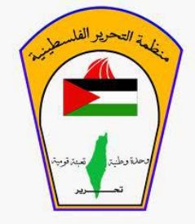

Israeli Settlers

While the PLO – Israel conflict was still happening something sensational was going on in Israel occupied Palestinian land. Israelis were settling down in Gaza and West Bank and they didn’t care about Palestinians’ opinion. Some of the Israelis moved into these territories for religious reasons, some did because the low housing prices due to Israeli government’s financial support and some did because they wanted to claim these lands for Israel. Some settlements were big cities and some were small communities. The settlers from Israel came with military soldiers to protect them and this affected Palestinians badly as their communities were being divided forcefully. This made the Israeli occupation much more difficult for Palestinians. Today there are more than 600,000 Israeli settlers in 143 locations in the West Bank (132) including East Jerusalem (11) even though settlements are illegal according to international law as reaffirmed by UN Security Council Resolution 2334 (2016)

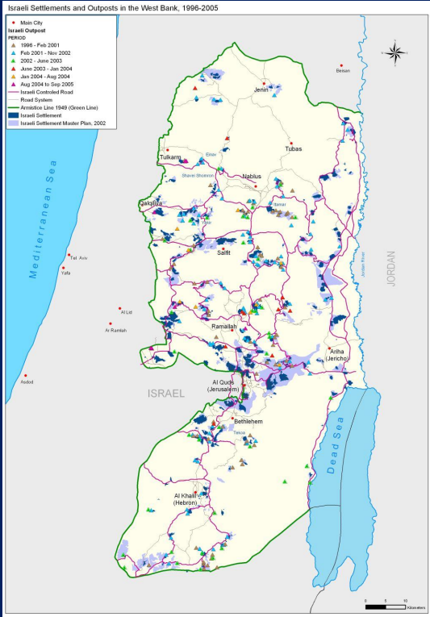

First Intifada
(1987-1993)
In 1987 Palestinian stress broke out into the Intifada, meaning ‘’uprising’’ in Arabic. Initially it wasn’t much of a threat to anybody’s livelihood consisting of boycotts and protests but soon became dangerous. Israel couldn’t overlook such violence and responded with heavy force. Hundreds of Israelis and over a thousand Palestinians lost their lives in the process. It was about this time when a group of Palestinians in Gaza thought PLO was too secular and too compromise-minded and because of this they founded Hamas, a violent extremist organization devoted to Israel’s destruction.

Oslo Accords (1&2) (1993)

After the First Intifada it was clear that both sides had to make peace. That’s when leaders from both sides signed the Oslo Accords. This was meant to be the first leap towards Israel potentially withdrawing from Palestinian land and ultimately making way for an independent Palestine. The Oslo Accords authorized the Palestinian Authority granting Palestinians slight bit of freedom to manage themselves in certain areas. Hard-liners on both nations ran counter to the Oslo Accords. Members of Hamas used suicide bombers to try to jeopardize the process. Israeli rightists protested peace talks, called Prime Minister Yitzhak Rabin a traitor and a Nazi. After the signing of Oslo 2, a far-right Israeli shot Rabin to death in Tel Aviv. This was an example of how both sides could use violence to prevent peace.

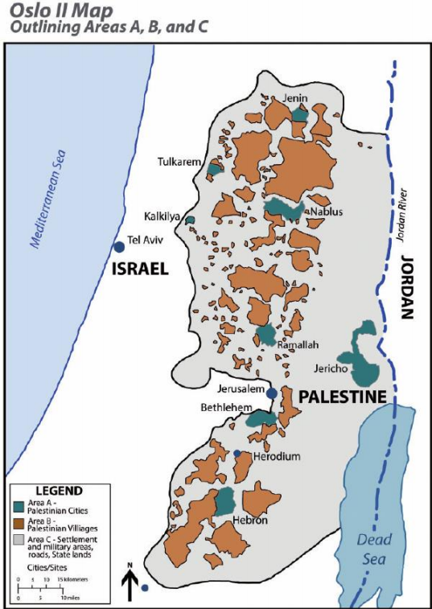
Second Intifada
(2000-2005)

Camp David II in 2000 was meant to bring peace onto these lands for good. When it failed, Palestinians were left hopeless. They thought that peace wasn’t coming anytime soon and this resulted in a Second Intifada which was much more violent and chaotic than the First Intifada. By the time it diminished a few years later, there were around 1000 Israelis and 3200 Palestinians dead. This had a massive effect on the IsraeliPalestinian conflict. Israelis started to believe that Palestinians were never going to accept peace as an option. Israeli politics drifted right, they started to build walls and checkpoints which are used to manage Palestinians. That same year Israel pulled out of Gaza leaving Hamas in charge after a civil war between the Palestinian Authority and Hamas. This divided Gaza and West Bank as Hamas ruled Gaza and Palestinian Authority ruled over West Bank. Israel put Gaza under a blockade and unemployment skyrocketed to %40 percent.

One-state and Two-state Solutions

There are currently two possible solutions for the IsraeliPalestinian conflict. One-state solution suggests that Israel, Gaza and West Bank should be united in order to achieve a single state in the middle east. The Two-state solution suggests that there should be two different countries, one for Israelis and one for Palestinians.

Overview at the humanitarian crisis

The Palestinian economy relies heavily on external assistance. It receives more than $300 for each of the 3.5 million Palestinians living in the West Bank and Gaza Strip – a level unprecedented in any other conflict since the Second World War. This level of aid has been maintained for over four years, exceeding the lifespan of other high-profile emergencies – such as Kosovo and Afghanistan – where aid peaked and waned. Aid is meeting the humanitarian needs of Palestinians in a conflict where the responsibility for these people, under international humanitarian law, lies with Israel as the Occupying Power.
The unique character of aid to the occupied Palestinian territory (OPT) is a function of the intense attention given to the Middle East peace process. Yet the role and impact of the more than $1 billion-worth of assistance received annually have not been seriously considered. Traditionally, aid has bolstered and supported peace agreements in the region. Following the 1993 Oslo Accords, donor states gave funding eagerly, in the expectation of peace and a viable Palestinian state. Although the peace process collapsed with the start of the 2000 Intifada, aid has continued to prop up structures such as the Palestinian Authority (PA), while the search for a new political settlement goes on. Aid today, therefore, lacks the political framework of a peace agreement. But without it the Palestinian economy would almost certainly collapse. That would provoke a calamity in terms of human suffering, further inflame violence and increase instability.
Maintaining stability, while the search for a peace agreement continues, is on the face of it a commendable aim. But there could also be negative implications. Funding will need to increase further to keep pace with the steadily worsening humanitarian situation and the decaying economy. While aid assuages the symptoms of the humanitarian crisis, there is less incentive to address the security issues that lie behind it. Without donor support, for example, Israel’s occupation of the West Bank and Gaza Strip would be much more problematic and expensive for Israel. And, like conflicts such as the Bosnian war in the 1990s, aid-induced stability can also make less urgent the search for peace.
Donor states also face a more immediate set of dilemmas, namely how their aid is spent. There is growing recognition of the legal implications of aid, particularly in light of the International Court of Justice (ICJ) decision in July 2004 that Israel’s construction of the West Bank Barrier is illegal. While maintaining stability and minimising human suffering, aid should not entrench Israel’s policies or establish ‘facts on the ground’ that could derail a future peace agreement.
HRW REPORTS
https://www.hrw.org/world-report/2019/country-chapters/israel/palestine
https://www.hrw.org/world-report/2018/country-chapters/israel/palestine
Humanitarian Dimension

Both the Palestinian people and the Israeli people have a profound desire for peace. Both have a right to live in their own State, on a land that is their own, so that their countries can develop and their children have a future. That prospect is at once distant and near. Distant because feelings of despair, humiliation and revolt are etched on many hearts and minds. This conflict has been dragging on for nearly forty years, and the Second Intifada has been under way for almost seven years. But the prospect is also very near in that everyone is well aware that this cannot go on, as the situation in the Palestinian territories, like the situation in the region as a whole, is more dangerous than ever. When you stand on the edge of a precipice, it takes determination and lucidity not to step into the void. Leaders in the region bear a tremendous responsibility and are going to need genuine political courage to respond to the expectations. There is no time to lose. The humanitarian situation in the Palestinian Territories has doubtless never been so bad. Nearly sixty percent of the Palestinian population currently lives below the poverty threshold of two euros a day whereas, before the Second Intifada started, they had one of the highest Human Development Indices in the Arab world. The poverty situation has deteriorated considerably since last year by some thirty percent. We are being forced to find new classifications for poverty and have coined the concept of extreme poverty for people who live on less than one euro a day. This is apparent from a whole series of indicators whose dispassionate precision should not hide the everyday human misery they reflect. For instance, thirty-five percent of the population, i.e. 1.3 million Palestinians, are victims of persistent food insecurity. A further million risk becoming victims if things remain unchanged. Nearly half of all children are anaemic. Infant mortality has risen fifteen percent in the last few years. Nearly a quarter of the population has no regular access to water. 3 There has been a considerable mobilisation of international humanitarian aid in response to this situation, especially by the European Union, which is the largest donor to the Palestinian Territories. In 2006 the European Commission, on behalf of the EU, gave 350 million euros in humanitarian assistance. This is a massive increase in comparison with previous years, and it means that the Palestinian Territories now constitute one of the Commission's largest humanitarian operations anywhere in the world. It is estimated that overall international aid – both humanitarian and otherwise – also expanded in 2006 and now totals more than 1.2 billion dollars. Ladies and Gentlemen, These overall figures are an indication of the magnitude of the crisis and the response that is required. But despite these efforts, the growth in aid has failed to check the rising needs. The humanitarian crisis is not restricted to the most vulnerable: the whole Palestinian population is suffering a severe socio-economic crisis. Any prospect of development or growth has almost entirely vanished, turning the Territories into what is largely a subsistence economy where day-to-day survival is all that counts. The longer the economic crisis continues, the more traditional safety nets and solidarity arrangements simply disappear, swelling the ranks of those who rely on external assistance to survive. This economic crisis has been exacerbated by the serious fiscal crisis affecting the Palestinian Authority. Contrary to what we sometimes hear, this crisis is not caused by the suspension of international direct budget support. Most of the effects of that suspension, which is linked to the political conditions regarding Hamas laid down by the Quartet, have been offset by the channelling of aid through the Temporary International Mechanism (TIM). The main cause is the suspension of transfers to the Palestinian Authority of income from taxes and customs duties that are levied by Israel on behalf of the Authority and constitute a large part of its budgetary revenue. The European Union has called on Israel to release this revenue. A tranche of 100 million dollars was released in December. This was a good start, but insufficient and woefully short of the target. The EU has called on the Israeli Government to use the TIM to transfer this revenue to the Authorities without compromising the political conditions set regarding Hamas. We hope and expect that the Israeli government will seize this opportunity. But even a substantial increase in international aid in response to this series of crises would be no guarantee of a lasting improvement. What we face here is not simply a crisis in terms of human needs: there is also a crisis in terms of the failure to respect humanitarian law. The conflict between Israel and Palestine has been marked by systematic and repeated violations of international humanitarian law. These violations come about in a number of ways. The most visible and most reprehensible violations concern acts of war and armed violence against civilian populations. Targeting such groups can never be justified when civilians are not playing a direct part in the conflict. We roundly condemn both rocket attacks on Israeli civilians and military operations that target the Palestinian people and their property. Let us not forget that, as an occupying power, Israel has a responsibility under international humanitarian law to protect and assist civilians. 4 In a conflict situation, the warring parties must abide by the principle of proportionality in their use of force. Unfortunately, it cannot be denied that this conflict has been marked by a disproportionate use of unjustified force, and that this has often aggravated the situation. Another area in which international humanitarian law has been violated concerns restrictions on access and movement. The system of closure and control that Israel has instituted in the Palestinian Territories, combined with the construction of a road system exclusively for the benefit of the settlements, is without doubt the single most decisive cause of the current humanitarian crisis. Dividing the territory into discontinuous blocks and preventing or limiting movement in an arbitrary and unpredictable manner with more than 800 mobile checkpoints and 80 fixed ones destroys any possibility of economic development in the Territories. How many lorry loads of goods and agricultural produce have gone to waste because of this system? How many hours have Palestinian workers and labourers lost because of this system? The situation continues despite the Agreement on Movement and Access (AMA), signed in November 2006 between the State of Israel and the Palestinian Authority. At the Karni crossing in the Gaza Strip last March a mere 40 lorries went through, compared with the 400 provided for in the Agreement. The Rafah international crossing has been open for only 11% of its working hours. I am pleased to learn that the situation has improved markedly in Karni in recent days, but there is no need for an extensive study to understand the impact this system of control is having on the economic development of the Territories. Humanitarian organisations face the same barriers, and movements of staff and humanitarian goods are severely curtailed. A glance at the figures for February and March this year shows that 71 ambulances were either refused access or forced to wait for lengthy periods. These security constraints on humanitarian relief cause delays and push up the cost of assistance. ECHO, the European Commission's Humanitarian Office, has estimated that the additional expense has raised the cost of assistance by between 15 and 20%. There can be no justification for hindering humanitarian operations: our actions are neutral and impartial, and are aimed only at improving the day-to-day existence of the most vulnerable sections of the population, especially women, children and the elderly. Ladies and Gentlemen, It would clearly be wrong to talk of violations of international humanitarian law without addressing the violations that have the most serious political consequences. The construction of the separation barrier may in itself seem shocking. But it is after all up to Israel to choose the most suitable means of defending its own security. The line that the barrier follows may be an obstacle when it comes to resolving the question of borders, although a negotiated solution may resolve that. The real problem comes when the exact line followed on the ground cannot be justified for reasons of security. I visited a Palestinian family near the village of Mash’a whose house is surrounded by the barrier on three sides and who are obliged to go through a barrier equipped with detectors every time they leave their house. The family lives under siege and in a permanent state of terror. How can national security concerns possibly justify such measures? Is there not a risk that, by taking the checks to such an extreme, a feeling of humiliation and revolt will become more deep-seated in the collective memory? 5 The settlements are the other violation that has been constantly condemned by international law. The Israeli Government's decision to dismantle the settlements in the Gaza Strip was a difficult and courageous act. Unfortunately, many still remain in the West Bank, often forming genuine compounds deep in Palestinian territory. The Israeli Government has given an undertaking to halt the expansion of these settlements, and we welcome this. There are, however, settlers who ignore such decisions and continue their illegal occupation of the land. As noted above, the construction of a road network purely to link Israeli settlements has served to increase the fragmented nature of the territories and made movement all the more difficult for the people of Palestine. The danger here is that the Israelis' legitimate concern for their security and the security of the settlements risks becoming a de facto fragmentation of the Palestinian territory and blocking any prospect of development. The duty to respect international humanitarian law and to ensure that it is observed applies equally to political parties and to the Palestinian authorities. No political cause can justify recourse to terrorist actions that target civilian populations. Passing off terrorism as political resistance is inexcusable, and indoctrinating children about war and martyrdom is criminal. All such acts are flagrant violations of international humanitarian law. Let it not be said, however, that I am passing moral judgment. International humanitarian law is simply another name for the laws of war. It contains no moral judgment. It does not seek to support one side more than another and applies to both in equal measure. All violations should be condemned, whatever their provenance. Respect for the law is a reflection of the arguments for justice and humanity set out in the Geneva Conventions. International humanitarian law does not require a choice between state security and human security. On the contrary, it should serve to unite these two requirements. It is also an imperative which is in the interest of all parties. For, if poverty nurtures despair, injustice and humiliation invariably foment violence. War can never be assumed to constitute an exceptional circumstance under which such obligations can be avoided. International humanitarian law exists precisely to ensure that such pretexts are not invoked. I should add that the international community and, to some extent, humanitarian actors too are also partly responsible for a situation that has seen a constant increase in violations of international humanitarian law. In our desire to alleviate suffering at any cost, as no cost is too high for a human life, we have ended up living with and tacitly accepting a whole range of constraints. Our tolerance level is increasing all the time, and we have demonstrated tremendous creativity in learning to adapt. But this is also a terrible dilemma, as providing assistance without guaranteeing the rule of law amounts to a sort of acceptance of a de facto situation. We must not forget that assistance and humanitarian law are indissolubly linked. Ladies and Gentlemen, You could be forgiven for leaving with the idea that I have a very pessimistic view of this situation. But let me be quite clear. I believe we are approaching a turning point which might set in motion a movement in the right direction. The current situation is unsustainable. The economic crisis and the system of closure could cause the territories to explode into chaos, with a consequent breakdown of law and order and social solidarity. The rising tide of violence and banditry makes us fear the worst, and the regional situation that forms a backdrop has rarely seen such tension. 6 The proliferation of political and diplomatic initiatives to find a lasting resolution to the conflict is proof of a general awareness that we must act before it is too late. Thoughts must start turning to the possibility of compromise, which is in the interest of both peoples and both countries. A direct dialogue between civil society in the two countries is one possibility. The representatives of civil society in Israel and Palestine that I have met seek dialogue and cooperation. When politics leads to stalemate, citizens can show the way and help unblock the situation. It is therefore more important than ever to work towards strengthening the humanitarian dimension of the peace process. Improving the economic and humanitarian situation on the ground as it affects the day-to-day existence of individuals is a powerful means of preventing people from accepting the extremist messages of terrorists who feed off this climate of violence. Their ranks must be diminished, and their capacity to recruit suicide bombers, especially among the young, by preying on misery and despair must be curtailed. Tangible improvements in the humanitarian situation are possible: the recent faceto-face talks between President Olmert and President Abbas addressed access conditions and humanitarian issues. This high-level political commitment to such questions must be transformed into an ongoing mechanism that transmits the message to the grass-roots level of the state and security apparatus, passing on clear instructions to improve access and movement. Dialogue with humanitarian actors must also be stepped up to improve the predictability of security measures affecting them and thus avoid unnecessary delays. I felt that the Israelis I spoke to were willing to cooperate and find solutions. I welcome this development. The reporting of incidents must be improved, and cases of abuse must be presented in an objective and incontrovertible fashion, establishing the facts so that corrective measures can be taken. Security forces and the military must be made more aware of the need to respect international humanitarian law. Security begins with restraint and the exemplary conduct of the armed forces on the ground. Improvements in the situation will also require advances on the economic and financial fronts to prevent the institutional and fiscal collapse of the Palestinian Authority. Humanitarian aid is clearly essential, and for our part we shall continue to meet the needs of the most vulnerable. But aid for economic development is no less urgent. Returning to questions that are at the interface between international humanitarian law and the political process, such as the settlements or East Jerusalem, let us remember that their resolution can come about only in the context of negotiations on a final agreement. But we should avoid any policy that accepts the 'fait accompli' on the ground, as this merely complicates the search for an agreement. By way of conclusion, let me reiterate my faith in an ultimately successful outcome. Respect for essential humanitarian rights and international law is an important milestone on the road to peace. It is a solid reason for believing that there is still a place for humanity. And as long as there is humanity, there is still the possibility of building a relationship, a dialogue that will open the way to compromise and respect for mutual interests. "In giving rights to others which belong to them, we give rights to ourselves," said John Fitzgerald Kennedy: today, more than ever, his words take on a special resonance for this part of the world
F.iQuestionsitoiBeiAddressed

1.iHowicaniUNHRCiencourageirespectiforihumanidignityiwithinithe borders of Al-Quds?iHowicanithisibeiaccepted by Israeli and the Palestinian goverment

2. How could UN deliver peace to the region?

3.iWhatistepsishoulditheiinternationalicommunityitakeitoiholdicountriesiaccountableifori
Theiriviolations of human rights?i¹⁴

4.iHowidoieconomicifactorsiaffectitheiupholdingiofibasicihumanirightsiinithe Israeli-Palestinian conflict?iHow shouldiresourcesibeiallocateditoibestiprotectihumanirights?

5.iWhatishouldiUNHRC’silong-termiroleibeiiniaddressingithe emergence of the situation?

6. How to ensure trust between the governments of the 2 nations?

7. What to do about the Israeli settlements?

8. What to do about the 7 million displaced Palestinian?

9. How to divide the territory around Jerusalem?

10. How to deal with the radical government of Hamas?

11. How to provide aid to people behind the blockade in Gaza?

12. How to get the governments serious about starting peace negotiations?

Past UN Actions

This was a resolution that condemned Israeli settlements and was adopted with 14 votes in favour and a US abstention:
http://www.securitycouncilreport.org/atf/cf/%7B65BFCF9B-6D27-4E9C-8CD3-CF6E4FF96FF9%7D/SRES2334.pdf

This resolution called for an immediate, durable and fully respected ceasefire leading to the full withdrawal of Israeli forces from Gaza:
http://www.securitycouncilreport.org/atf/cf/%7B65BFCF9B-6D27-4E9C-8CD3-CF6E4FF96FF9%7D/Gaza%20SRES1860.pdf

This resolution declared Council support for the Annapolis peace process and its commitment to the irreversibility of bilateral negotiations:
http://www.securitycouncilreport.org/atf/cf/%7B65BFCF9B-6D27-4E9C-8CD3-CF6E4FF96FF9%7D/IP%20SRES1850.pdf

Bibliography

https://www.youtube.com/watch?v=iRYZjOuUnlU&t=282s https://www.vox.com/2015/5/14/18093732/israel-palestinemisconceptions http://guides.library.illinois.edu/c.php?g=348323&p=2347110
https://mfa.gov.il/MFA/AboutIsrael/Maps/Pages/1947%20UN%2 0Partition%20Plan.aspx https://www.palestineportal.org/learn-teach/israelpalestine-thebasics/maps/maps-1967-to-present/ http://londonprogressivejournal.com/article/view/2624/thesuffering-of-palestinian-refugees-in-jordan https://www.globalsecurity.org/military/world/israel/mapsevolution.htm http://orimgift.pw/SINA-ISRAL-EGYPTE-Israel-t-Israel-and.html http://thehigherlearning.com/2014/07/10/quickest-possibleexplanation-of-the-current-israeli-palestinian-conflict/ 26 https://www.arlenefromisrael.info/the-palestinian-liberationorganization-plo/ https://eeas.europa.eu/headquarters/headquartershomepage/48438/six-month-report-israeli-settlementsoccupied-west-bank-including-east-jerusalem_en http://poica.org/2007/10/evacuating-the-israeli-settlementsoutposts-or-not/ https://worldsymbolsblog.wordpress.com/2014/08/03/themeaning-of-the-hamas-symbol-and-miraculous-missilesreported-over-israel/ https://www.researchgate.net/figure/Map-of-Areas-A-B-and-Cafter-Oslo-II_fig1_276258691 http://borderlessnewsandviews.com/2012/05/09/in-defense-ofreason-part-1-yippie-ki-yay/ https://www.securitycouncilreport.org/undocuments/israelpalestine/

Mehmet BÜYÜK – Wishing great luck and mindfullness.
Associate Committee Director

